FLIGHT TICKET BOOKING SYSTM

TABLE OF CONTENTS

1. INTRODUCTION & OBJECTIVE
2. ADVANTAGES
3. TOOLS / ENVIRONMENT USED IN THE PROJECT
4. DATAFLOW DIAGRAM
5. ER DIAGRAM
6. MODULES
7. DATABASE DETAILS
8. SCOPE OF FUTURE APPLICATION
9. SUMMARY
10. BIBLIOGRAPHY

- INTRODUCTION & OBJECTIVE
Airline reservation systems were first introduced in late 1950s as relatively simple standalone systems to control flight inventory, maintain flight schedules, seat assignments and aircraft loading. The modern airline reservation system is comprehensive suite of products to provide a system that assists with a variety of airline management tasks and service customer needs from the time of initial reservation through completion of flight.
One of the most common modes of travel is traveling by air. Customers who wish to travel by air nowadays have a wide variety of airlines and a range of timings to choose from. Currently most of the airlines have made provision for online reservation of their flights. My Project intends to serve of results, which can help them in their travel plans.

The objective of this project is to create an airline reservation system where a traveler can request all flight information as per their journey dates. They can get information regarding time, cost, etc all at the same time and place. When the customer calls the Counter Assistant will enter the customer’s details (flight requirements) in the system. The system displays all the available airlines, schedules and price. This system would help the airline to better serve its customers by catering to their needs. The site would use a Database to hold this information as well as the latest pricing and availability information for their airlines.

- ADVANTAGES OF THE PROJECT:
The general advantages are:
- You can do it any time of the day, wherever you are. You can book a flight at home or somewhere else.
- Requires less time for completion of job done.
- Decreases the chances of error.
- Should work smoothly and very fast.
- Saves time and manpower.
- User friendly and can be handled easily by anyone having basic computer Knowledge.
- Changing or canceling a ticket is simple when you've booked an airfare online.

- TOOLS / ENVIRONMENT USED IN THE PROJECT:
SOFTWARE REQUIREMENTS

Operating System : Windows XP/2003 or Linux
User Interface : HTML, CSS
Client-side Scripting : JavaScript
Programming Language : Java
Web Applications : JDBC, Servlets, JSP
IDE/Workbench : My Eclipse 8.6
Database : Oracle 10g
Server Deployment : Tomcat 6.x

HARDWARE REQUIREMENTS
Processor : core2duo
Hard Disk : 160GB
RAM : 1GB or more

Technology Stack:
- Front End : JavaScript, HTML,CSS,JAVA
- Back End : Oracle 10g

- DATA FLOW DIAGRAM:
A graphical tool used to describe and analyze the moment of data through a system manual or automated including the process, stores of data, and delays in the system. Data Flow Diagrams are the central tool and the basis from which other components are developed. The transformation of data from input to output, through processes, may be described logically and independently of the physical components associated with the system. The DFD is also know as a data flow graph or a bubble chart.
DFDs are the model of the proposed system. They clearly should show the requirements on which the new system should be built. Later during design activity this is taken as the basis for drawing the system’s structure charts. The Basic Notation used to create a DFD’s are as follows:
1. Dataflow: 4. Data Store:

2. Process:

3. Source:

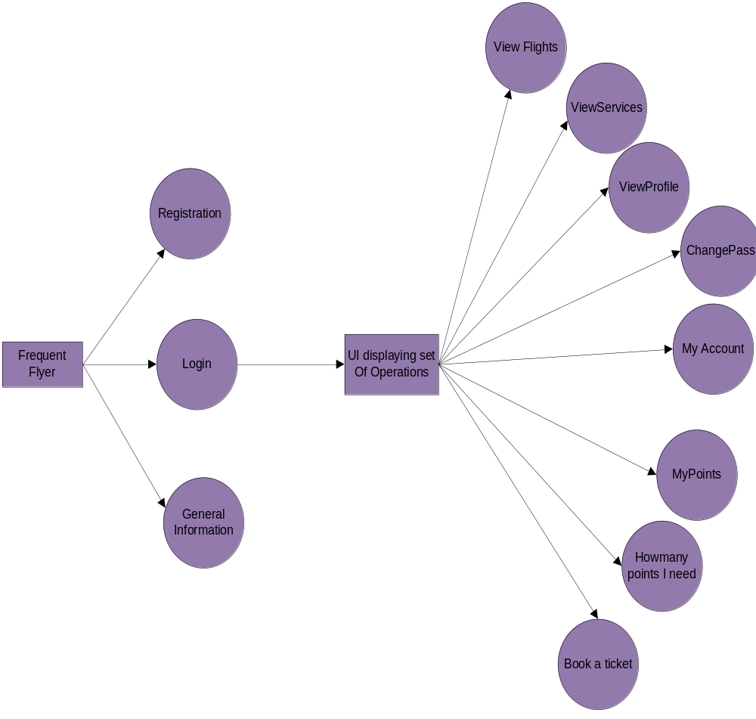

Fig1 : Level1 Data Flow Diagram For Frequent Flyer

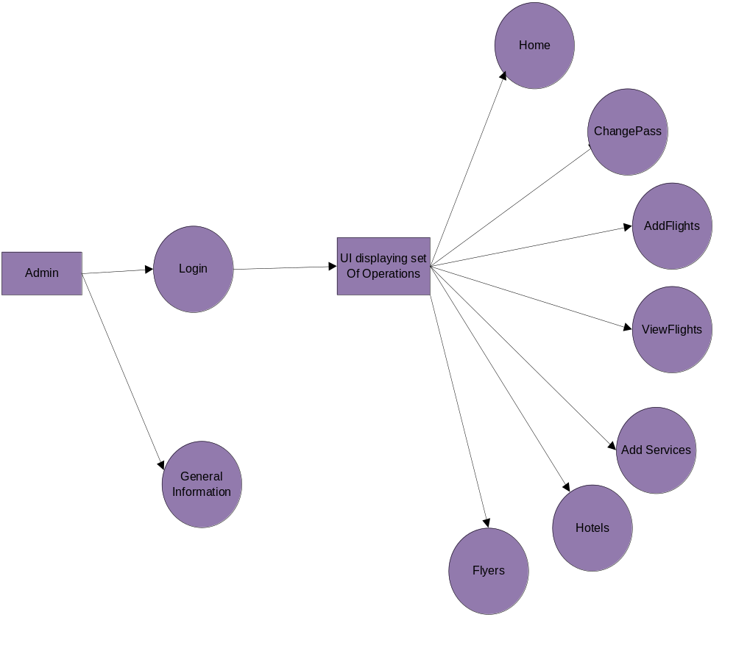

Fig1 : Level1 Data Flow Diagram for Administrator

5. E-R DIAGRAM:

The following diagram depicts various entities involved in the Assignment Management System and relationships between those entities.
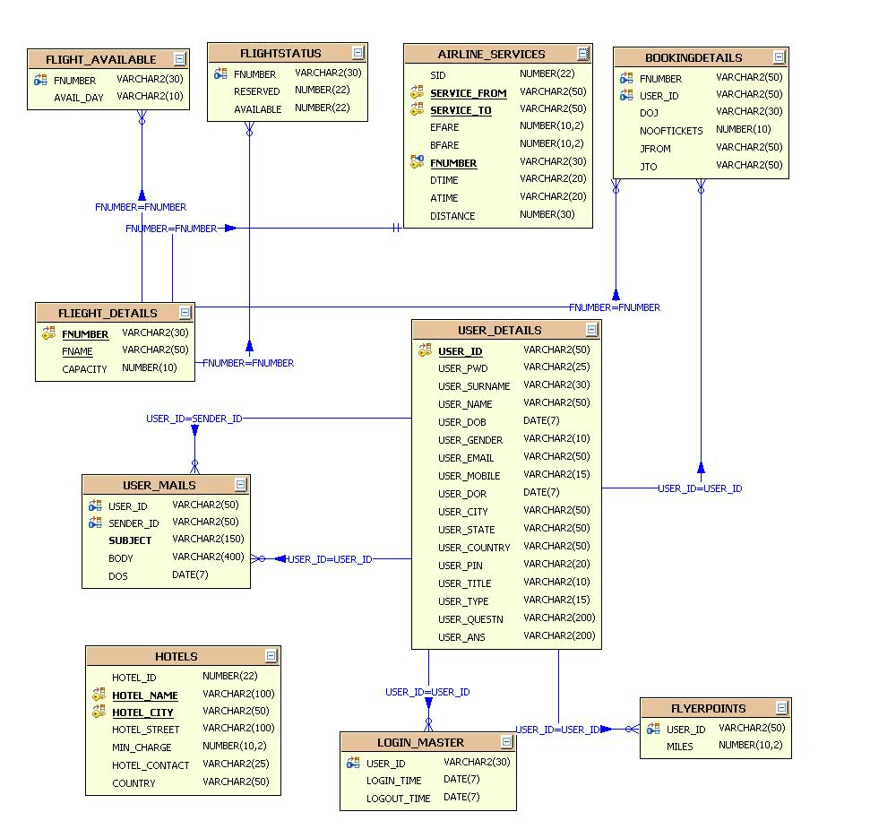
Fig3 : E-R Diagram
6.MODULES:
The system after careful analysis has been identified to be presented with the following modules:

The Modules involved are

- Authentication and Security Module
- Admin Module
- Flyer Module.
- Flight Management Module.
- Service Management Module.
- Reports Module.

MODULES DESCRIPTION

Module description for each module mention on top

Admin Module:
In this administration module, admin should login to the system to access this system. After he logged Admin can add flight details and also he/she can modify the flight details belong to particular airline services. And also he/she has able to add services like hotels in different countries.
And admin can also monitor the users login and logout details.

Flight Management Module:
In this module admin can add flight details and also he/she can modify and delete the flight details. This module serves the user like on which dates flights available and how many seats are available to book a ticket and also this module will help the frequent flyer to know the how many he/she needs to travel from one point to another point with free ticket.

Frequent Flyer Module:
In this module the flyer should register to access this system. Frequent flyer means, the person who travel frequently by air. The frequent flyer should login to the system, to utilize the benefits of the frequent flyer offered by particular airline services. This system maintains the complete details of the registered user and also its facilitate to update and modify the details of the user. In this module the user can book a ticket and see the status of the flight between two points. This system facilitates to know how many points the user need to travel from one place to another place with free ticket.

Security and authentication module:

In this module this system stores the details of the registered user with safe and secure manner. And it can allow only authentication user to access the system. This system prevents the unauthorized accessing and malfunctioning.

Service Management Module:
In this module the administration can add the services provided by the airline service and he can also modify the services .He has to add service from source to destination and distance between two points.

Report Module:
In this module the data from the database will be shown in tabular format as report to the users of this system.

7. MAJOR TABLES WITH TENTATIVE COLUMNS:
AIRLINE_SERVICES

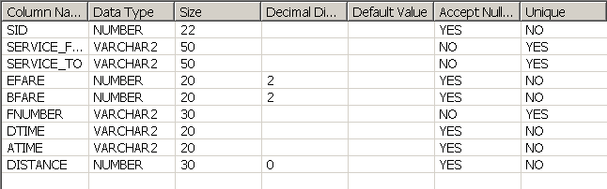

BOOKINGDETAILS

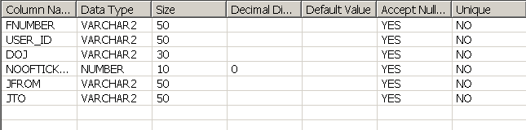

FLIEGHTDETAILS

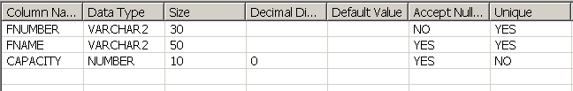

USERDETAILS

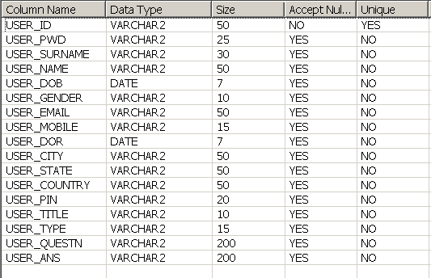

USERMAILS

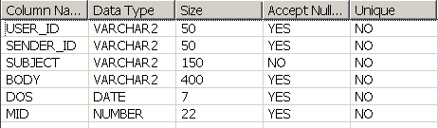

FLYERPOINTS

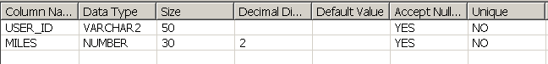
8. SCOPE OF FUTURE APPLICATION
It is not possible to develop a system that makes all the requirements of the user. User requirements keep changing as the system is being used. Some of the future enhancements that can be done to this system are:
- As the technology emerges, it is possible to upgrade the system and can be adaptable to desired environment.
- Because it is based on object-oriented design, any further changes can be easily adaptable.
- Based on the future security issues, security can be improved using emerging technologies.
- Attendance module can be added
- sub admin module can be added

9. SUMMARY:
The AWBS for Airlines Industry is a web-based application for primarily providing training to the employees who provide customized solutions to meet organizational needs.
This application software has been computed successfully and was also tested successfully by taking “test cases”. It is user friendly, and has required options, which can be utilized by the user to perform the desired operations.

The software is developed using Java as front end and Oracle as back end in Windows environment. The goals that are achieved by the software are:

- Instant access.
- Improved productivity.
- Optimum utilization of resources.
- Efficient management of records.
- Simplification of the operations.
- Less processing time and getting required information.
- User friendly.
- Portable and flexible for further enhancement.

10. BIBLIOGRAPHY
(1) Java Complete Reference by Herbert Shield
(2) Database Programming with JDBC and Java by George Reese

(4) Wikipedia, URL: http://www.wikipedia.org.

(5) Answers.com, Online Dictionary, Encyclopedia and much more, URL: http://www.answers.com
(6) Google, URL: http://www.google.co.in

